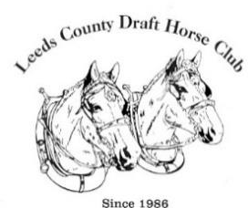
Leeds County Draft HORSE Club

Draft Horse Clinic 2023/Introduction to Harnessing & Driving
Participant Information Sheet & Waiver of Liability Form
Date: Saturday, May 6, 2023 – 8:30 am to 4:00 pm (Rain Date Sunday, May 7, 2023 – you will be contacted by the club in advance if we must change to the rain date) - please arrive at 8:00 am to register and sign the waiver form.
Where: Lombardy Fair Grounds (corner of HWY 15 and Kelly’s Road)

Details:
Provide contact details (phone number and civic address) to brianAmcintosh60@gmail.com
Pre-payment ($50/participant or $30 LCDHC member) is required to register for the clinic and no refunds will be given within 30 days of the date of the clinic. Payment can be made electronically to treasurer.lcdhc@hotmail.com or by cheque sent to: Ken Clark, 130 Maitland St. Smiths Falls. Ontario K7A 4S7 Please ensure your NAME & PAYMENT DETAIL are included in the e-transfer information.
For safety reasons we require you to wear closed toe shoes or boots (safety boots are recommended).
Safety measures will be a priority during the clinic and you must acknowledge that you are participating at your own risk and sign the attached Waiver of Liability Form at the registration desk on the date of the clinic.
You must be 16 years of age or over to participate OR if between 12 & 16 be accompanied by a parent.
A full information package will be made available in advance of the clinic and Certificate issued on completion.

Clinic Schedule:
8:00 to 8:30 – Registration and Assignment of Teamsters to Participants (draw from hat at registration desk unless previously specified at time of registration)
8:30 to 8:45 – Welcoming Remarks, Administrative Details Introduction of Teamsters, General Safety Overview
8:45 to 10:00 – Teamster Time – introduction to the draft horse, safety, handling & training, grooming & care of the horse, hoof care & shoeing, harness types & fit, harnessing process
10:00 to 12:00 – ground driving instruction/demonstration with your assigned Teamster & “teamster shuffle” where participants are welcome to ground drive other teams to experience different breeds of horses.
12:00 to 12:45 - Lunch Break – PLEASE BRING YOUR OWN LUNCH
12:45 TO 15:30 hitching and driving instruction & demonstration, participant driving & “teamster shuffle” where you are welcome to join different Teamsters to experience a variety of horses & hitches.
15:30 - 16:00 – Participant evaluation forms – Certificates – closing remarks.

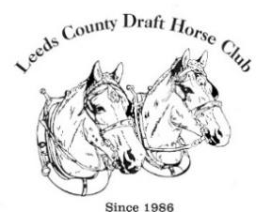
Leeds County Draft HORSE Club

Draft Horse Clinic 2023 /Introduction to Harnessing & Driving - Waiver of Liability
To participate in the 2023 Draft Horse Clinic we request you read the attached “Acknowledgement of Risk and Release of Liability” Form. PLEASE BRING THIS FORM AND BE PREPARED TO SIGN IT AT THE TIME OF REGISTRATION ON THE DAY OF THE CLINIC.

In addition, we request that you consider signing the following Optional Waiver and returning it at the time of registration.

Optional Waiver:
The LCDHC takes photos during the clinic to post on its face book and web pages and would like your approval to include any photos that you may be a part for this purpose.
I therefore give my approval to have my photo taken and that any such photographs are the property of the LCDHC and can be used for LCDHC purposes including promotions and advertising.

Name: Signature:

