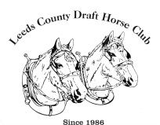
Leeds County Draft HORSE Club 2023/Introduction to Harnessing & Driving

ENTRY FORM

NAME: ______________________________________________

ADDRESS: __________________________________________

PHONE #: ___________________________________________

EMAIL: _____________________________________________

Send all registration forms to: brianAmcintosh60@gmail.com
Brian 613 608-7806

